Early Tasks and Notes:
- Respond to communication email from Tett Centre and submit text regarding the next Guild Sales event. Tania and Flo have been receiving this email communication.
- Respond to communication from Profile Magazine and submit text regarding the next Guild Sales event. Tania Craan has been receiving this email communication.
- Respond to Convenor request and put out a “Call For Pots” communication prompting Guild members to plan for upcoming pottery photo session. Publicity has requested Sale Convenor add the initiation of the “Call For Pots” communication to their task list.
- Responding to Convenor request and organize pottery photo session with official photographer. Ideally the session is held before the Sales meeting allowing enough time for publicity material to be designed and printed. Publicity has requested that the Sale Convenor add the initiation of the photo session to their task list.
- Consider new entrance and street signage. Current signs have our previous logo and are in black and white. They could be modeled after the retractable banner procured for the Community Engagement Initiative. New signs should include a QR code that links to the Guild website.
- See “SOCIAL MEDIA INFO” page in sales binder updated by Flo, Jan 2025. It has important information including some credentials. Included in this document as Appendix 4.
- After accommodating Kingston Holiday Market’s request to change the Guild Holiday sale dates, the Holiday Market agreed to a Guild Sales Promotion plan that Tania developed. This is included as Appendix 2. Publicity Team feels that the formal agreement is no longer required but, a better option is to cross-promote each other’s sales without asking. Cross-promoting is a good way to get more reach and could be done with other organizations as well. A starting list of organizations would include Kingston Holiday Market.
Kingston Holiday Market contact is: kingstonholidaymarket@gmail.com
Tasks:
- Design and Print Sale rack cards, and posters
- Due prior to the October Sales meeting so they can be distributed to sales participants.
- Card should include the date of sale, hours of the sale each day, location, KPG logo, an image of relevant pottery, preferably from one or more of the participating potters.

- Include a QR code that links to the Guild website page for the Sale.
- Printer Used in the past and currently:

PrintFusion Inc.
323 Bath Road
Kingston, ON K7M 2X6
(613)389-6611
Attn: Jeff Thurlby
Email: jthurlby@printfusion.ca
2025 Holiday Sale
See Invoice as Appendix 5
Postcards – Printed 1,000
Posters (8.5x11) – Printed 20. Library took 14. Others can be used on directional signs.
Posters (11x17) – We printed 3. Posted in Guild Studio Windows
2025 Spring Sale
Postcards – Printed 342
Posters (8.5x11) – Printed 32
Posters (11x17) – Printed 0

- Name tags and table cards
- 2025 Holiday Sale started using generic name tags instead of tags with the individual potter’s names. Logistics team will contact Publicity at least 2 weeks before the sale if more generic name tags are needed.
- Logistics team will confirm and notify Publicity at least 2 weeks before the sale of any new or lost table cards that are needed. The table cards remain individualized to the participating potter.

- Distribute cards and Posters

- Distribute 8.5x11 Posters to Library
- Go to the information desk at the Main branch and ask to have the posters distributed to Library branches again this sale. The assistant was pleased to help and knew exactly the number required. However, this is not always the case, and you might need to explain that this is a standard request from the Guild.

- Post Posters in Guild Studio Windows
- 3 Posters were ordered for posting in the Guild Studio Windows. One each in the display window, main studio window and kiln room windows.
- Place postcards on the outside of the Guild Studio windows for the passing public to help themselves to.

- Distribute Postcards to Information Stands on the various floors of the Tett Centre
- Distribute print material to participants and local businesses
- The Tourist Information Office was a suggested spot for Publicity postcards. They would have a rack for advertising.

- Community Education Initiative

- A Community Education Initiative was introduced for the 2025 Holiday Sale. The event supports the Guild’s commitment for community engagement. Where possible future sales should include an educational event. The decision to include an event should be finalized at the first Publicity Team meeting.
- Purpose specific signage for the Guild Studio doorway has been procured for these events.
- Elizabeth Munro, Patty Petkovich and Anne Merritt organized the first event and may be the best source for lessons learned.

- Mail Chimp Newsletter
- Send out a newsflash advertising the sale through Mail Chimp two weeks prior to sale.
- Use the same design created for the postcards, include the location, the dates and the times of the sale.
- Mail Chimp Username: kingstonpottersguild@gmail.com PW: Potters1967!
- Social Media
- Ask Sale participants to send in their images at least 2-3 weeks before the sale to use and create a social media campaign using Facebook, Instagram and any other relevant social media platform. Images should be sent to Tania or Flo.
- Send a communication to Sale participants to make their social media accounts public during our promotion of the sale if they want us to repost their posts and reels.
- Engage local politicians and arts personalities (ie. Brianne Franklin, Director of the Tett, Nicole Daniels, Director of the KAC) for a “Pick Your Favorite Pot” event as was done by the Hillpottery Guild. See example in Appendix 3.
- Boost Social Media Posts to Increase Engagement
Plan a Social Media Ad campaign that leverages boosting Social Media posts to increase engagement. The campaign would adhere to an approved budget and payment method.
- Print Media
Contact any print media and online media that is relevant as well as the local tv channel.
- Marketing List for KPG sales (updated Nov 2025)

Website: http://kingstonpottersguild.ca
Email: kingstonpottersguild@gmail.com
Facebook: @KingstonPottersGuild
X: @YGKPottersGuild
Instagram: kingstonpottersguild

Profile Kingston Magazine
Copy and image need to be sent in early as they have an early deadline. Tania has been taking care of this. See Early Task section above.
Contact Kath Leverette crotherslek1860@gmail.com

Tett Centre
Contact Communications & Marketing Coordinator, Emma MacGregor-Mitchell (Nov 2025). Tania has been taking care of this. See Early Task section above.

- Large format advertising signs

- Company is Thousand Island Magnet Signs. Run by Matthew Brumsey (29 Elgin St., Trenton, ON). Email: thousandislands@magnetsigns.com; phone: 613-643-8813. This includes the sign on highway 15.
- Signage should include sale dates, times, and location.
- City of Kingston is no longer allowing signs for non-City events. See Appendix 1 for details.

- Website contacts for posting sale ads

1. Visit Kingston (visitkingson.ca), also known as Tourism Kingston
Go to https://www.visitkingston.ca/events and fill out form. Put the sale times in the description box, not the start/stop fields. Also include a blurb about the event and the sale advertising photo. If you need assistance contact visit@tourismkingston.com

2. New site for fall 2025: YGKEvents.com
Go to the above website and find the link for submitting an event or use the following link (https://www.ygkevents.com/submit-an-event/). Fill out the form. The text posted for the 2025 fall sale was:
Get ready to shop one of Kingston’s most beloved seasonal traditions - the Kingston Potters’ Guild Annual Holiday Sale returns to the stunning Malting Tower at the Tett Centre from November 20 to 23, 2025. This festive four-day event showcases the incredible work of dozens of local potters and ceramic artists, offering a unique opportunity to browse and buy handmade pieces that range from charming ornaments and cozy mugs to elegant vases, bold statement pieces, and functional everyday ware. Whether you’re hunting for the perfect holiday gift, a one-of-a-kind home accent, or something special just for yourself, you’ll find something to love at this thoughtfully curated sale.

Expect a warm, welcoming atmosphere filled with colour, creativity, and craftsmanship. Each piece is handcrafted by members of the Kingston Potters’ Guild, reflecting a range of styles, techniques, and inspirations. It’s a celebration of local artistry and an ideal destination for anyone who values high-quality, handmade work.

Visitors are encouraged to come early for the best selection - the sale is known to draw big crowds and popular items tend to go quickly. And with the sale spread over four days, there’s plenty of time to return for second visits or bring a friend.

3. Kingston Arts Council (https://www.artskingston.ca)
Complete an online form to list the event on their website, need to give the organizer’s
name and email as the submitter. They usually take 4-5 days to post.

4. The Garrison Newspaper (thegarrison@forces.gc.ca)
Send an email with the copy text and an image

5. Kijiji (Kijiji.ca) (Look for Kijiji Kingston)
login: kingstonpottersguild@gmail.com
password: Ceramists@1967
Place an “ad” using the copy text and an image

6. Kingston Community Watch
(https://globalnews.ca/pages/kingston-community-watch)
Complete an online form to list the event on their website

7. Kingston Daily
This is a radio station but they post events on their website and may promote them on air. Complete an online form at kingstondaily.ca using the link under the “Local Events” dropdown menu.

8. Rotary Club (www.kingstonrotary.ca)
Complete an online form to list the event on their website

9. Kingston Today (https://kingston.today/today)
Use the “add” dropdown menu to add sale info to their calendar. You need to do this separately for each day/time the sale is on in order to enter the correct times the sale is open.

10. Love Kingston/Support Kingston (supportkingston.ca)
This site requires a business to register a specific person with their contact info, email and password. hello@supportkingston.ca (343-453-5566). Site was not used for fall 2025 since the membership of the Publicity team changes frequently.

Appendix 1


PLEASE DO NOT REPLY WITHIN THIS BOX.
Subject: City of Kingston:Question from constituent re: signage for Potters Guild [Reference#: 251106-000283]
Reference #: 251108-000044
(Chantel) (11/18/2025 10:59 AM)
Good morning,

I have now heard from our Recreation & Leisure Department and they have confirmed that they are only allowing City-sponsored temporary signs in front of City parks and recreation facilities and no other signs will be permitted to be placed in these areas.

Let me know if you have any further questions.

Thanks,

Chantel Satov (she/her/hers)
Licensing & Enforcement Agent
Licensing & Enforcement Services

(Chantel) (11/10/2025 11:26 AM)
Good morning Nancy,

I will look into this for you and get back to you as soon as I hear back from the department at the city who gives/denies permission for signs to be placed on city property.

Thanks,

Chantel Satov (she/her/hers)
Licensing & Enforcement Agent
Licensing & Enforcement Services

(Nancy Martin) (11/08/2025 12:48 PM)
Please direct this email to Chantal Satov, Licensing & Enforcement Agent.
Hi Chantal,
I am following up on the issue about placing advertising signs on City property that was initially raised by Anne Lougheed.
First, some background. For many years we have rented signage from Thousand Island Magnetsigns (Morgan and Matthew Brumsey of Trenton, ON). This company has looked after applying for and obtaining permits from the City on our behalf. We usually rent 2 signs, one which was traditionally on private property and the other was on city property.
We have had signs in several locations over the past number of years, for example, at the corner of Front and Days at Centre 70 or in Portsmouth Village at the harbour (along King Street).
The fall, Mr Brumsey informed me that when he went to the City to apply for our permit he was told " The City, as of Oct 1, no longer allows non city funded organizations to have signs on City property.” This new policy clearly impacts not only the Kingston Potters’ Guild’s advertising practices but also has a large impact on Mr Brumsey’s business.
Although it is too close to our sale dates to be able to put out additional signage now, we would appreciate clarity on this new rule for future reference.
Best regards,
Nancy Martin (on behalf of the Kingston Potters’ Guild)
Please reply to this email or quote the reference # in future correspondence relating to this inquiry.

The City of Kingston acknowledges that we are on the traditional homeland of the Anishinaabe, Haudenosaunee and the Huron-Wendat, and thanks these nations for their care and stewardship over this shared land.

Appendix 2 – Kingston Holiday Market Plan

Spring Sale Promotions
• In April, when you post a graphic promoting your spring sale on Facebook and Instagram in the caption mention our upcoming sale. A minimum of two times in April would be nice.
a. Example being “If you are looking for another opportunity to shop local and support some great artists, head over to @kingstonpottersguild for more information on their Spring sale May....”
• On our Instagram we have a variety of posts with pictures of our potters’ creations. Repost in April, onto your story a few (2-4) of our potters’ creations with a possible caption “Our friends at the @kingstonpottersguild always blowing us away with their beautiful creations!”
• One week before our spring sale repost our Spring Sale graphic onto your Instagram story with a caption or graphic like “See you @kingstonpottersguild Spring Sale #shoplocal”.
2024 Holiday Sale Promotions
• After the date of the holiday sale has been released, create a Facebook post with a picture from our social media of people creating a piece of pottery with a caption like “It’s so important to support local artists if you’re looking for a chance to spread some cheer this holiday season, head over to the @kingstonpottersguild Holiday Sale to purchase some beautiful ceramic pieces. We will see you there!” If you like we can provide the picture for the post.
• During the first week of November, once we’ve announced our holiday sale, on Instagram, repost one of our pottery photos onto your Instagram story and tag us with a caption like “our friends @kingstonpottersguild gearing up for their upcoming Holiday Sale, head over to their page for more details!”
• Upon the posting of our Holiday Sale graphic, repost onto your story and tag us with a “Join Us” or “See you there!” Sticker or caption.
• Two weeks before our holiday sale create a post of our potters’ creations tagging us (maybe a carousel of pictures) with the caption “Christmas is just around the corner! Surprise your loved ones with beautiful one-of-a-kind creations made by the members of the @kingstonpottersguild. Check out their page for information on their upcoming Holiday Sale.”
• 5 days before our Holiday Sale repost one of our posts on your Instagram story with the caption “5 Days until the @kingstonpottersguild Holiday Sale! We can’t wait to see your beautiful creations! #supportlocalartists”

Appendix 3 – Hillpottery Guild Local Politician Event Media

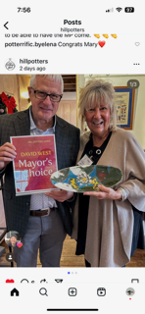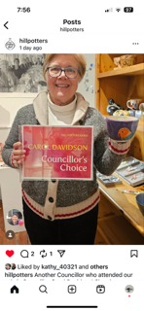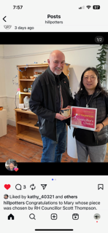

Appendix 4

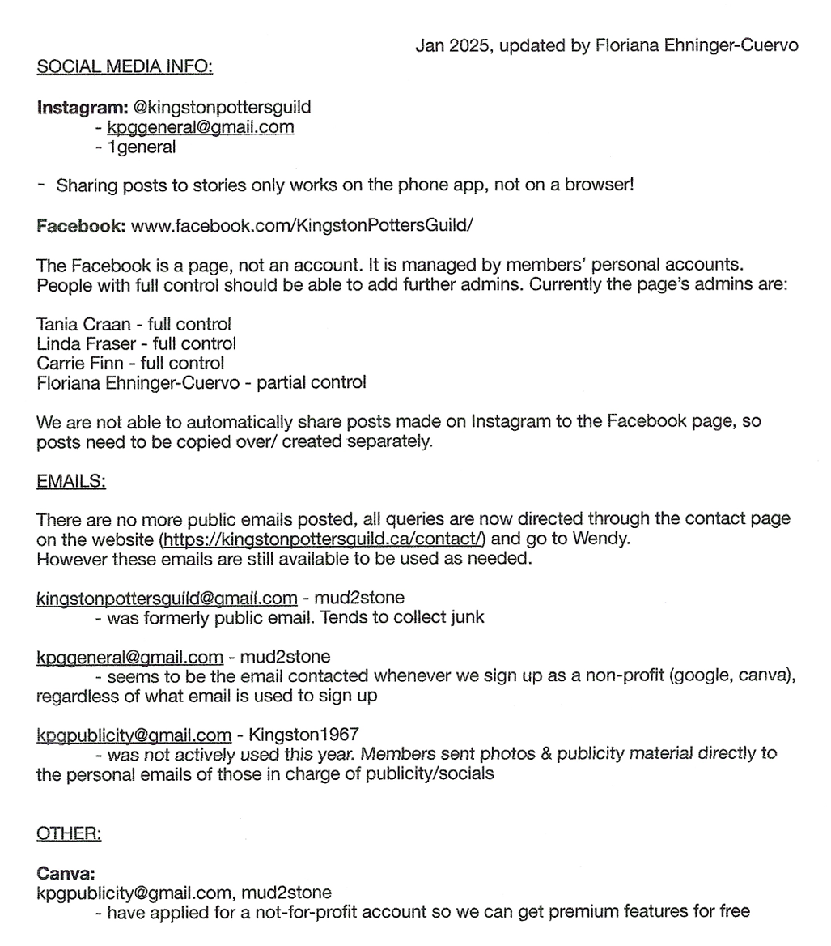

Appendix 5

